Facility Book System (Club)

# Disclaimer

The current system is only for educational purpose and may contain a number of bugs.

# Features

When running the system, you can try the following features.

## Manage Members

### Create and Edit Member

### List and Delete Members

## Manage Facilities

### Create and Edit Facilities

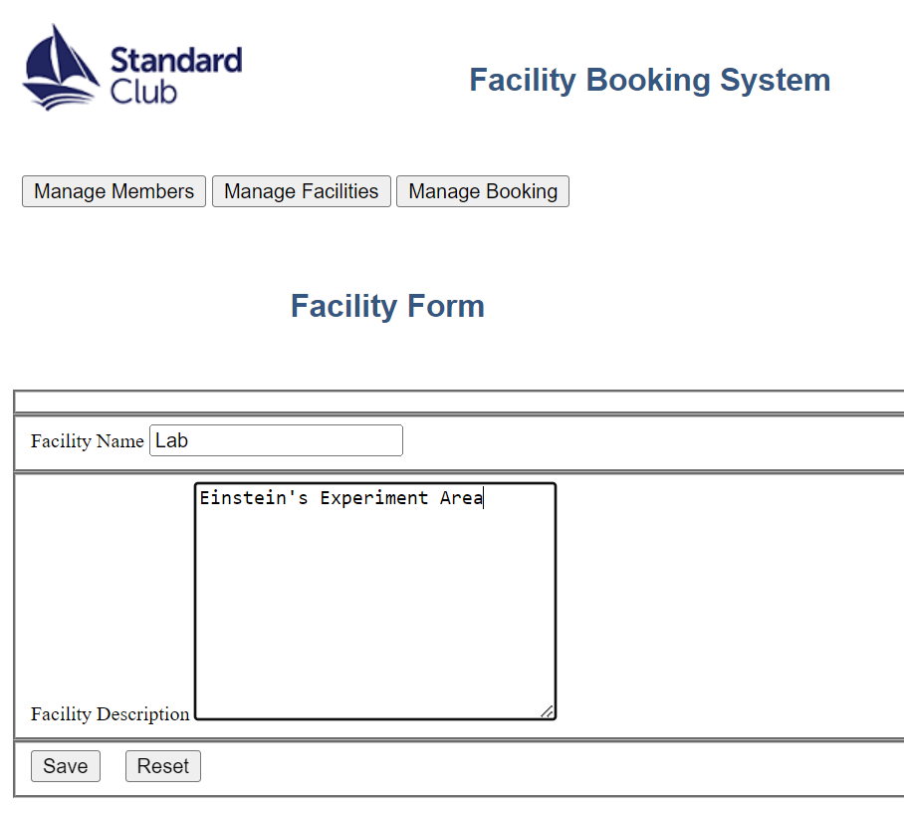

### List and Delete Facilities

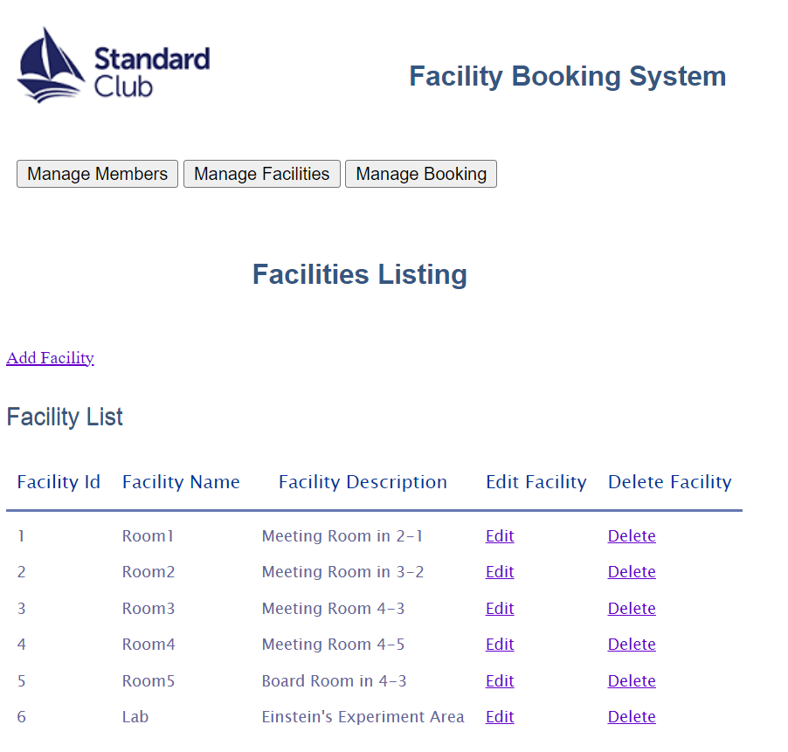

## Manage Bookings

### Create Bookings

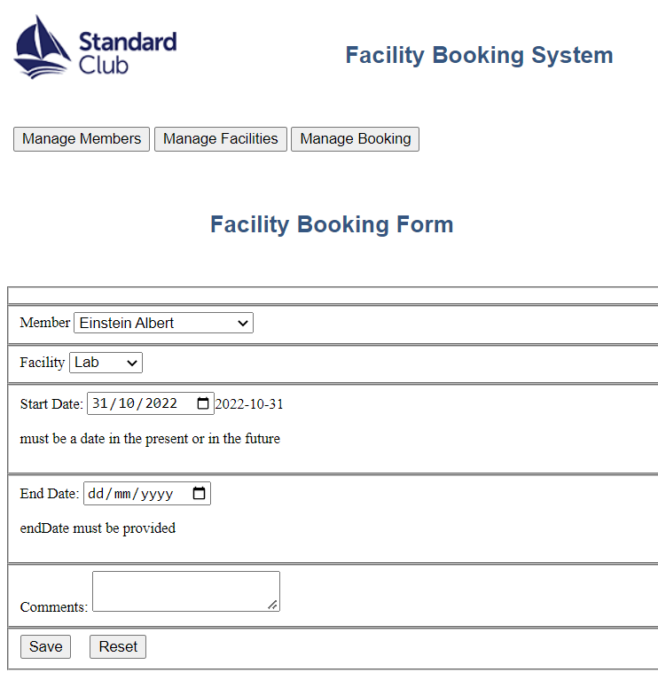

### List and Cancel Bookings

